Josue Choizy
CS210
Project 2

// Invest.cpp
#include <iostream>
#include <iomanip>
using namespace std;
int main() {
//Declare variables to store inputs
float initialInv;
float annualInt;
float monthlyDep;
float months;
float years;
float totalAmt;
float interestAmt;
float yearTotalInt;
//Display form to user
cout << "********************************\n";
cout << "********** Data Input **********\n";
cout << "Initial Investment Amount: \n";
cout << "Monthly Deposit: \n";
cout << "Annual Interest: \n";
cout << "Number of years: \n";
//Wait for input from user
system("PAUSE");
//Get data from user
cout << "********************************\n";
cout << "********** Data Input **********\n";
cout << "Initial Investment Amount: $";
cin >> initialInv;
cout << "Monthly Deposit: $";
cin >> monthlyDep;
cout << "Annual Interest: %";
cin >> annualInt;
cout << "Number of years: ";
cin >> years;
months = years * 12;
//Wait for input from user
system("PAUSE");
//Set total amount to initial investment to be updated
totalAmt = initialInv;
//Display year data without monthly deposits
cout << "\nBalance and Interest Without Additional Monthly Deposits\n";
cout << "=======================================================================\n";
cout << "Year\t\tYear End Balance\tYear End Earned Interest\n";
cout << "-----------------------------------------------------------------------\n";
for (int i = 0; i < years; i++) {
//Calculate yearly interest
interestAmt = (totalAmt) * ((annualInt / 100));
//Calculate year end total
totalAmt = totalAmt + interestAmt;
//Print results to table showcasing only two decimal points
cout <<(i + 1) << "\t\t$" << fixed << setprecision(2) << totalAmt << "\t\t\t$" << interestAmt << "\n";
}
//Set total amount to initial investment to be updated
totalAmt = initialInv;
//Display year data with monthly deposits
cout << "\n\nBalance and Interest With Additional Monthly Deposits\n";
cout << "=======================================================================\n";
cout << "Year\t\tYear End Balance\tYear End Earned Interest\n";
cout << "-----------------------------------------------------------------------\n";
for (int i = 0; i < years; i++) {
//Set yearly interest to zero at the start of the year
yearTotalInt = 0;
for (int j = 0; j < 12; j++) {
//Calculate monthly interest
interestAmt = (totalAmt + monthlyDep) * ((annualInt / 100) / 12);
//Calculate month end interest
yearTotalInt = yearTotalInt + interestAmt;
//Calculate month end total
totalAmt = totalAmt + monthlyDep + interestAmt;
}
//Print results to table showcasing only two decimal points
cout << (i + 1) << "\t\t$" << fixed << setprecision(2) << totalAmt << "\t\t\t$" << yearTotalInt << "\n";
}
return 0;
}
Banking App Pseudocode
Function DisplayMenu()
DISPLAY main menu
Shows options for data input:
- initial investment
- monthly deposit
- annual interest
- number of years
- press any key to continue option
END function;

Function InterestTables()
CALCULATE year-end balances WITH monthly deposits – input by user in menu
CALCULATE year-end earned interest WITH monthly deposits – input by user in menu
CALCULATE year-end balances WITHOUT monthly deposits
CALCULATE year-end earned interest WITHOUT monthly deposits
DISPLAY console for balance and interest WITHOUT monthly deposits for entered number years
DISPLAY console for balance and interest WITH monthly deposits for entered number years
END function;

Function CalculateInterest(OpeningAmount, DepositedAmount, InterestRate)
monthly_interest = (OpeningAmount + DepositedAmount) * ((InterestRate/100)/12)
RETURN monthly_interest
END function;

Function main()
PROMPT user for initial investment amount
PROMPT user for monthly deposit amount
PROMPT user for interest rate
PROMPT user for number of years of investment
CALCULATE monthly interest based on number of years entered
END function;
Flowchart

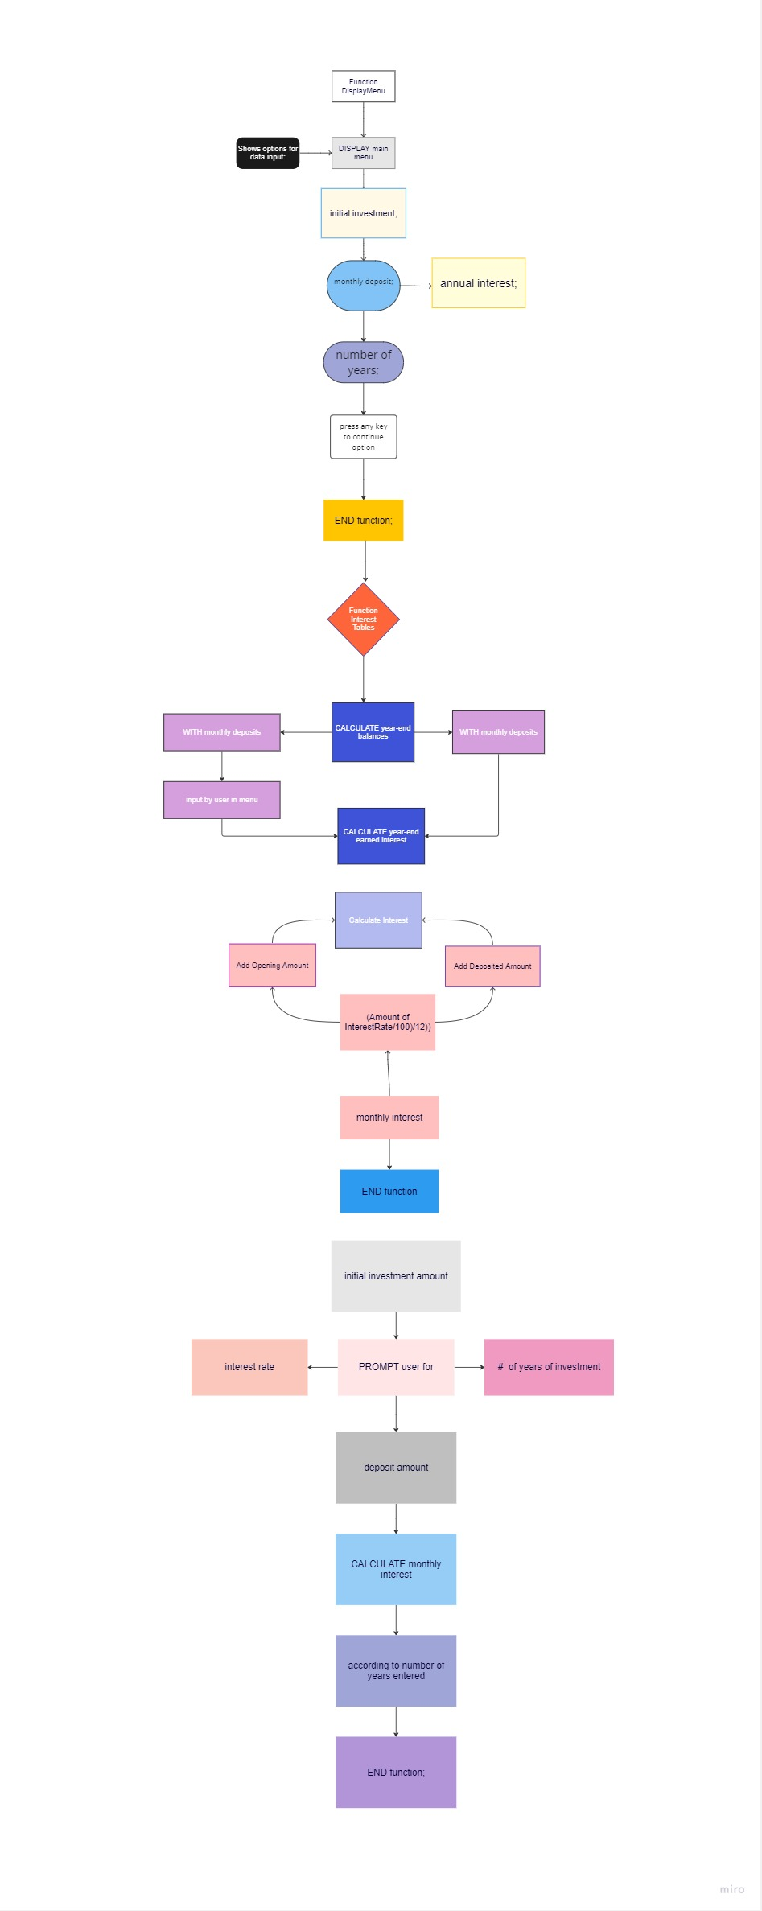

Summarize the project and what problem it was solving.
- The program has several primary functions which include calculating the year-end balances and earned interest with and without monthly deposits that are input by the user through a menu. Additionally, it can display the console for the balance and interest without monthly deposits for a specified number of years, as well as the console for the balance and interest with monthly deposits for a specified number of years.
- What did you do particularly well?
This program does a good job of providing a clear and organized display of financial information. It prompts the user for input on various financial variables, performs calculations on those variables, and then displays the results in an easily readable table format.
Additionally, the program provides the user with the option to view two separate tables, one with monthly deposits and one without, which allows the user to see the impact of regular deposits on their total investment. The use of fixed and setprecision(2) also ensures that all numbers are displayed with two decimal places, improving the accuracy of the calculations.
Overall, the program is well-structured, easy to follow, and provides valuable financial information to the user

- Where could you enhance your code? How would these improvements make your code more efficient, secure, and so on?

The challenges in programming include debugging and fixing errors in code and understanding complex algorithms or math concepts. To overcome these challenges, programmers can use debuggers and logging to identify problems, break down problems into smaller steps, and seek resources such as online forums, documentation, and educational materials. Building a strong support network involves joining online communities, attending meetups or conferences, seeking out mentors or colleagues, and utilizing online learning platforms and resources such as Stack Overflow, GitHub, and Codecademy.
Input validation should be implemented to ensure that user input is valid and falls within acceptable ranges, such as checking for negative values or validating the annual interest rate input to be between 0-20%. This would increase the program's security and reduce the likelihood of errors.

To make the program more robust and user-friendly, it should include error handling routines to handle runtime errors, such as divide by zero errors or file access errors.

The code could be refactored by creating separate functions to improve readability and maintainability. For instance, a function could be created to calculate the year-end balances and interest with and without monthly deposits.

To enhance the user interface, the program could incorporate more visual aids such as graphs and charts to assist the user in visualizing the investment growth over time. This would make the program more engaging and user- friendly.

To optimize the program's performance, it could use more efficient algorithms and data structures, such as utilizing a vector or array to store calculated year-end balances and interest instead of repeatedly printing to the console.

- Which pieces of the code did you find most challenging to write, and how did you overcome this? What tools or resources are you adding to your support network?
- What skills from this project will be particularly transferable to other projects or course work?
The project requires a strong understanding of programming fundamentals, including control structures, functions, and data types. The project also involves complex math and financial calculations, such as compound interest and annuities, which are widely applicable in various fields. Input validation, error handling, and code refactoring are also essential skills required in the project, which are transferable to other software development projects. Designing a user interface that is easy to use and visually appealing is also an important skill. In summary, these skills will be valuable in various software development projects and courses, regardless of the specific programming language or field.
- How did you make this program maintainable, readable, and adaptable?
The program uses functions, proper naming conventions, comments, modularity, and separation of concerns to make the code maintainable, readable, and adaptable. Functions are used to break down the code into smaller, reusable chunks, while meaningful names and comments make it easier to understand and maintain the code. The program also separates the concerns of user input, calculation, and output, making it easier to modify and improve each component separately. Additionally, the program has been designed with modularity in mind, making it easy to add or remove features as necessary.

